Name: Laiba Asim
Sa[p id: 65230

Lab 7:

Task 1:
Write an assembly language program that find the square of a number entered by user. Print the result

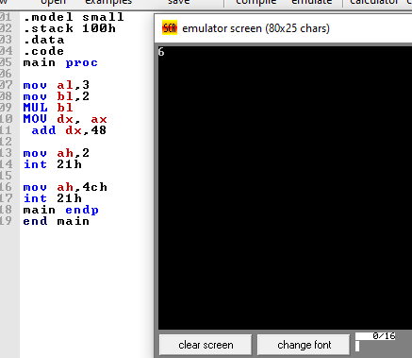

Task 2:
Write an assembly language program that find the cube of a number entered by user. Print the result on screen.
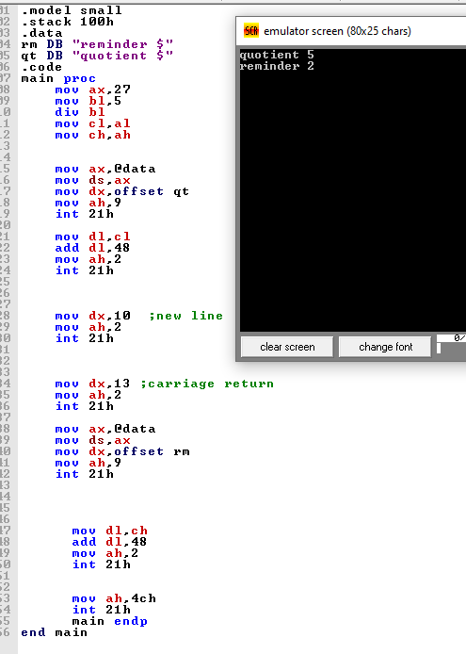

Task 3:

Perform multiplication of two numbers entered by user. Print the result on screen.

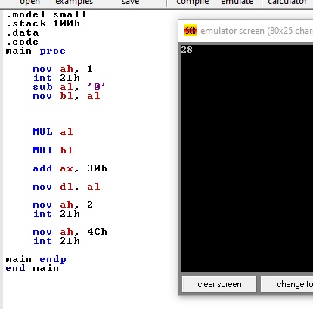

Task 4:

Write an assembly language program that finds the area of a triangle.
Hint: Area of triangle = ½ (Base ×Height)
